

CSE2102

DATABASE SYSTEMS DESIGN &

INFORMATION MANAGEMENT

**DATABASE REQUIREMENT SPECIFICATION DOCUMENT**



|  |  |
| --- | --- |
| **TOMEKA BOBB** | **1026904** |
| Kushina Guyadeen | 1028619 |
| Shane Jardeen | 1028101 |
| Ravin Panday | 1027338 |
| Colin Semple | 1026725 |



Good Shepard Academy

Database for GSA

Database Specification Document

September, 2018

REVISION SHEET

|  |  |  |
| --- | --- | --- |
| Revision | Date | Revision Description |
| 0 | 09/09/18 | -Database Specification Document |
| 1 | 28/09/18 | -Added logical and conceptual designs |
| 2 | 24/10/18 | -Revised cover page, conceptual and logical diagrams  -Moved conceptual and logical diagrams to section 2.0  -Redesigned aesthetics of document  -Added ‘About the Group’ section |
| 3 | 02/11/18 | -Added Application Functional Specification |
|  |  |  |
|  |  |  |
|  |  |  |
|  |  |  |
|  |  |  |
|  |  |  |
|  |  |  |
|  |  |  |
|  |  |  |
|  |  |  |
|  |  |  |
|  |  |  |
|  |  |  |
|  |  |  |
|  |  |  |
|  |  |  |

TABLE OF CONTENTS

|  |  |  |
| --- | --- | --- |
| **CONTENTS** | | **PAGE NO.** |
| 1.0 | General Information | | 5 |
|  | 1.1 | Problem Statement | 5 |
|  | 1.2 | Purpose | 5 |
|  | 1.3 | Scope | 5 |
|  | 1.4 | System Overview | 5-6 |
|  | 1.5 | Project References | 6 |
|  | 1.6 | Acronyms and Abbreviations | 6 |
|  | 1.7 | Points of Contact | 6 |
|  |  |  |
| 2.0 | Database Identification and Description | | 7 |
|  | 2.1 | Conceptual Database Design | 7 |
|  | 2.2 | Logical Database Design | 7 |
|  | 2.3 | Database Identification | 8 |
|  | 2.4 | Special Instructions | 8 |
|  |  |  |
| 3.0 | Database Administrative Information | | 9 |
|  | 3.1 | Responsibility | 9 |
|  | 3.2 | Storage Requirements | 9 |
|  | 3.3 | Recovery | 9 |
|  |  |  |
| 4.0 | About the Group | | 10 |
|  | 4.1 | Github Accounts | 10 |
|  | 4.2 | Group Member Responsibilities | 10 |
|  |  |  |
| 5.0 | Application Functional Specification | | 11 – 12 |
|  |  |  |
| 6.0 | Mock-up | | 13 - 17 |
|  | 6.1 | Homepage | 13 |
|  | 6.2 | Logged-in | 14 |
|  | 6.3 | Child Sheet | 15 |
|  | 6.4 | Financial Information | 16 |
|  | 6.5 | About Us | 17 |

1.0 | GENERAL INFORMATION

## 1.1 | Problem Statement

Good Shepard Academy, a private pre-school day-care, would take in approximately 200 children a year. Records of each child are kept manually in the head office.

Annually, there would be a record book at the door for parents to sign when they arrive at the day-care to receive their child at the end of the school day. This record book is called the ‘sign-in and sign-out book’. It is used primarily to track student’s attendance and get an idea of the regular individuals that would collect the child.

The book would consist of the following: date, name of child, parent name and contact number. However, due to the late-for-work trend, some parents would leave their child without signing the book.

It is a very tedious task for teachers to go through the record book every day for student’s attendance.

The head of Good Shepard Academy thinks it is best to move away from keeping manual records in order to have a more efficient school system.

Jane Doe, a database expert, has had her services requested to assist in the transition to digital record keeping.

## 1.2 | Purpose

This document, which provides detailed information of the database model L.G.T Company, is intended to be used to enhance Good Shepard Academy’s current record system.

## 1.3 | Scope

Most emphasis will be placed on student records and daily records of student attendance.

## 1.4 | System Overview

Good Shepard Academy will have an online website where persons can register their child, get a response from the head, and information will be stored in the school’s database.

For attendance records teachers can sort database and digitally tick present or absent and get automatically-generated attendance records.

|  |  |
| --- | --- |
| System Overview | Details |
| System Name | L.G.T |
| System type | Client Server Application |
| Operational Status | In development |
| Database Name | Good Shepard Academy Database |
| Users | Parents, GSA recoding staff, LGT company |
| User Requirements | A GSA register online account for parents, a login password for GSA staff |
| User groups | Parents, GSA recoding staff, LGT company |

*Table showing system overview details*

## 1.5 | Project References:

* Fundamentals of Database Systems / Ramez Elmasri, Shamkant B. Navathe - 6th Ed.
* 4-1 Database functional Specification document
* System Requirement Specification Template

## 1.6 | Acronyms and Abbreviations

* L.G.T- Let’s Go Technological
* GSA DB- Good Shepard Academy Database

## 1.7 | Points of Contact

|  |  |  |  |
| --- | --- | --- | --- |
| Role | Name | Email | Telephone no# |
| Project Manager | Ezekiel Rayman | ezekielrayman15@yahoo.com | 592 677-3341 |
| Database manager | Jane Doe | janedoe25@gmail.com | 655-2343 / 225 8834 |
| System Specialist | Ububu Khan | [ububukhan@hotmail.com](mailto:ububukhan@hotmail.com) | 592 654 3210 |

2.0 | DATABASE IDENTIFICATION AND DESCRIPTION

## 2.1 | CONCEPTUAL DESIGN

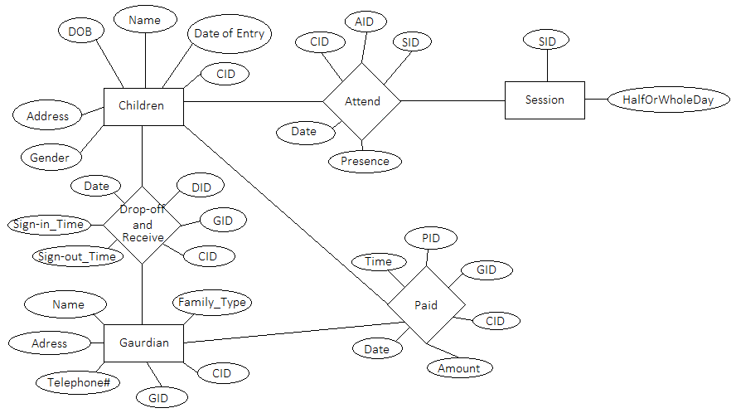

## 2.2 | LOGICAL DESIGN

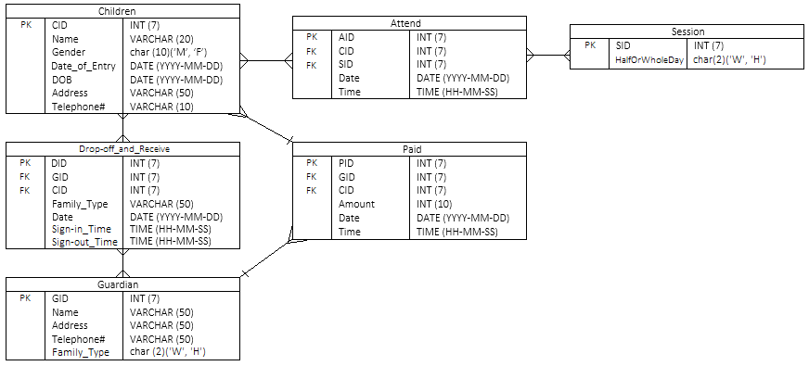

## 2.3 | Database Identification

Database name – GSA DB

## 2.4 | Special Instructions

When marking students as present or absent on the database, the students should confirm for themselves that their names were marked correctly by visually verifying on the screen.

3.0 | DATABASE ADMINISTRATIVE INFORMATION

## 3.1 | Responsibility

Database Manager Jane Doe would assume the role of database administrator. Former staff member Ububu Khan would assume the roles of system administrator and security administrator.

## 3.2 | Storage Requirements

A hard drive with at least 15 gigabytes of free space would need to be set aside for data.

## 3.3 | Recovery

To ensure that information is not lost in the event of a crash, data would be backed up daily. This way, should something catastrophic happen, the database Administrator can retrieve most if not all of the data.

## 3.4 | Error Handling

|  |  |
| --- | --- |
| **Potential Error** | **Mitigation/Damage Control** |
| Database crash | There must always be a backup source for data |
| Accidental deletion of Data | Data Redundancy |
|  |  |

*Note: In the case of any error in the database, it is wise to contact the company owner.*

4.0 | ABOUT THE GROUP

4.1 | Github Accounts

|  |  |
| --- | --- |
| STUDENT | GITHUB ACCOUNT LINK |
| Tomeka Bobb | https://github.com/mekabobb |
| Kushina Guyadeen | https://github.com/kushkush18 |
| Shane Jardeen | https://github.com/shanejardine |
| Ravin Panday | https://github.com/codeAart |
| Colin Semple | https://github.com/Calkidd |

4.2 | Group Member Responsibilities

Though all group members will contribute to all aspects of the development of this database and its accompanying documentation, work falling in specific domains will be delegated to select individuals within the group. Those who have been delegated a role will maintain responsibility for accomplishing tasks that fall within its domain.

The three domains and their ‘managers’ are:

|  |  |  |
| --- | --- | --- |
| Image result for document iconDocumentation | Back-end | Image result for circle art iconFront-end |
| Primarily, this would encompass the responsibility of ensuring that the database specification document is completed appropriately and adhered to when doing further development. | This would encompass all programming, database command and query-related work. | This would encompass all design-related work for both documentation as well as for the website that the database will be accessed through. |
| **TOMEKA BOBB,**  **KUSHINA GUYADEEN** | **RAVIN PANDAY** | **COLIN SEMPLE,**  **SHANE JARDEEN** |

5.0 | APPLICATION FUNCTIONAL SPECIFICATION

Upon entering the homepage of the website, the user, if signed out, will be able to select the following tabs:

* Sign-up
* Log-in
* About Us

If signed in as a standard user, options available will be to select from the following tabs:

* View Child Sheet
* View Financial Information
* Logged in as ‘user name’
* About Us

If signed in as an administrator, the user will instead have access to a CRUD tab and its functionality, which will allow the administrator to create records, read records, update records and delete records.

Selecting Sign-up will take the user to the sign-up page where they can create an account. This account will then need to be validated by an administrator before the user has standard user permissions.

Selecting Log-in will prompt the user to enter their username and password to allow them the functionality of the website application.

Selecting the ‘View Child Sheet’ tab will take the user to a page where they can see the attendance of the children tied to their account as well as any special information regarding the child.

Selecting the ‘View Financial Information’ tab will take the user to a page where they can see the financial information regarding the children tied to their account. This would include amount paid for a given term, amount owed for a given term and an invoice that is both viewable and downloadable for each term.

Selecting the ‘About Us’ tab will take the user to a page that gives a history of the daycare as well as contact details.

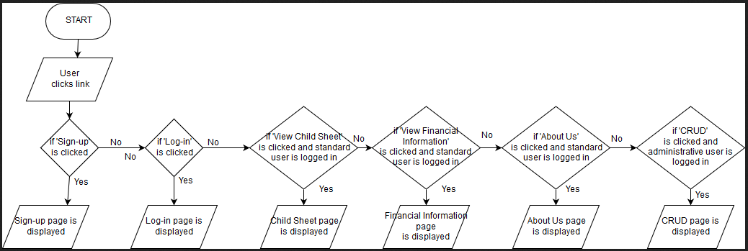

6.0 | MOCK-UP

6.1 | Homepage

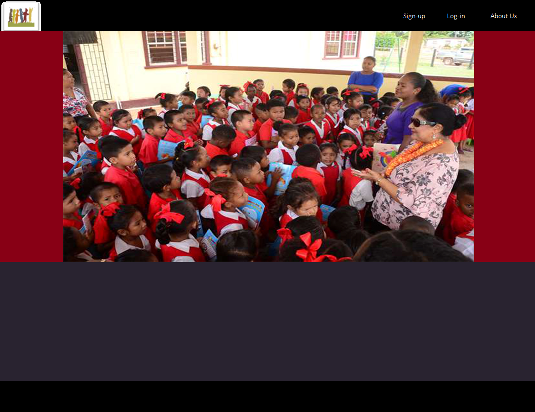

6.2 | Logged-in

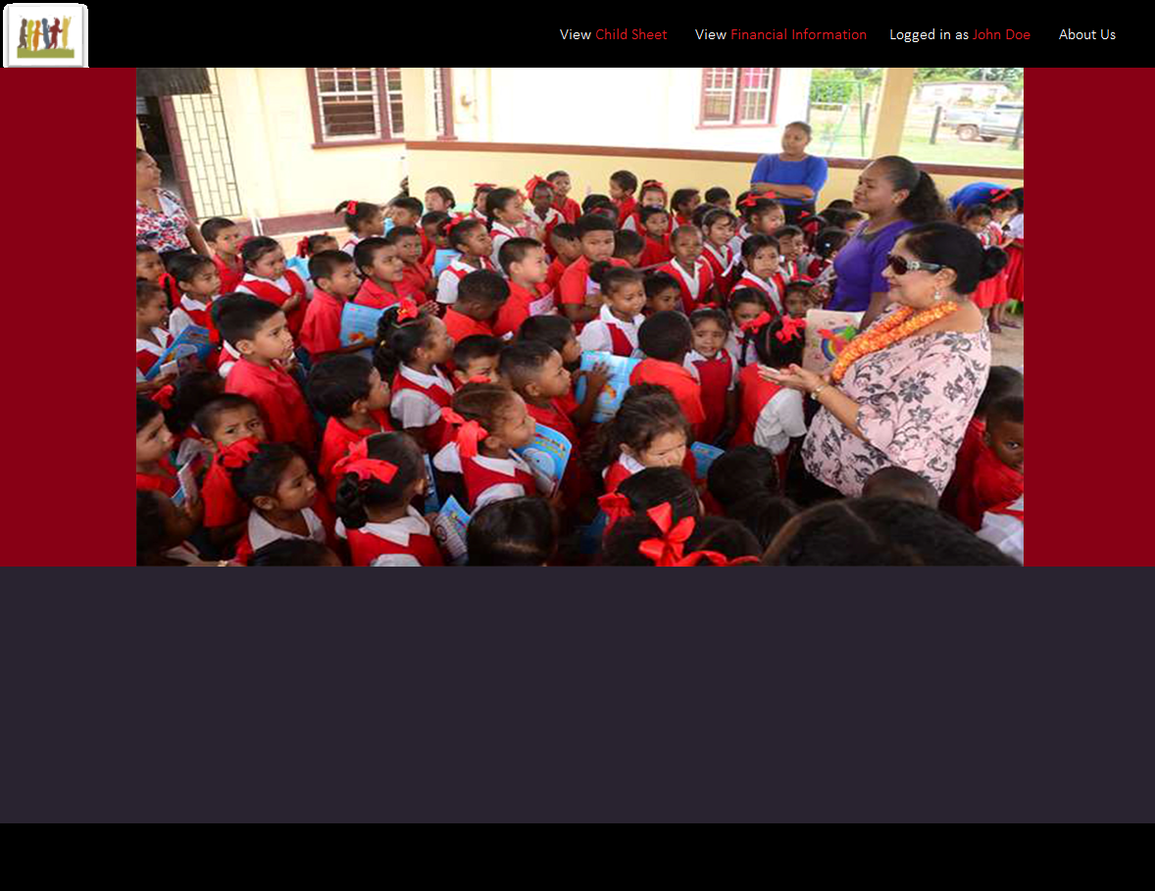

6.3 | Child Sheet

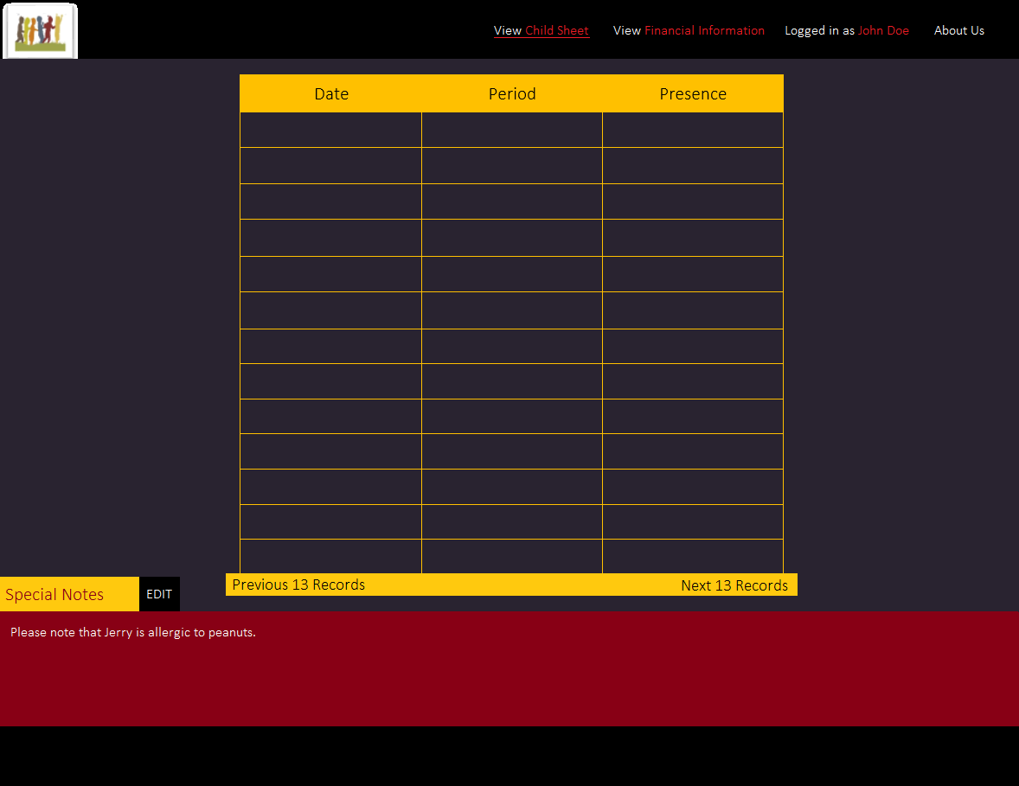

6.4 | Financial Information

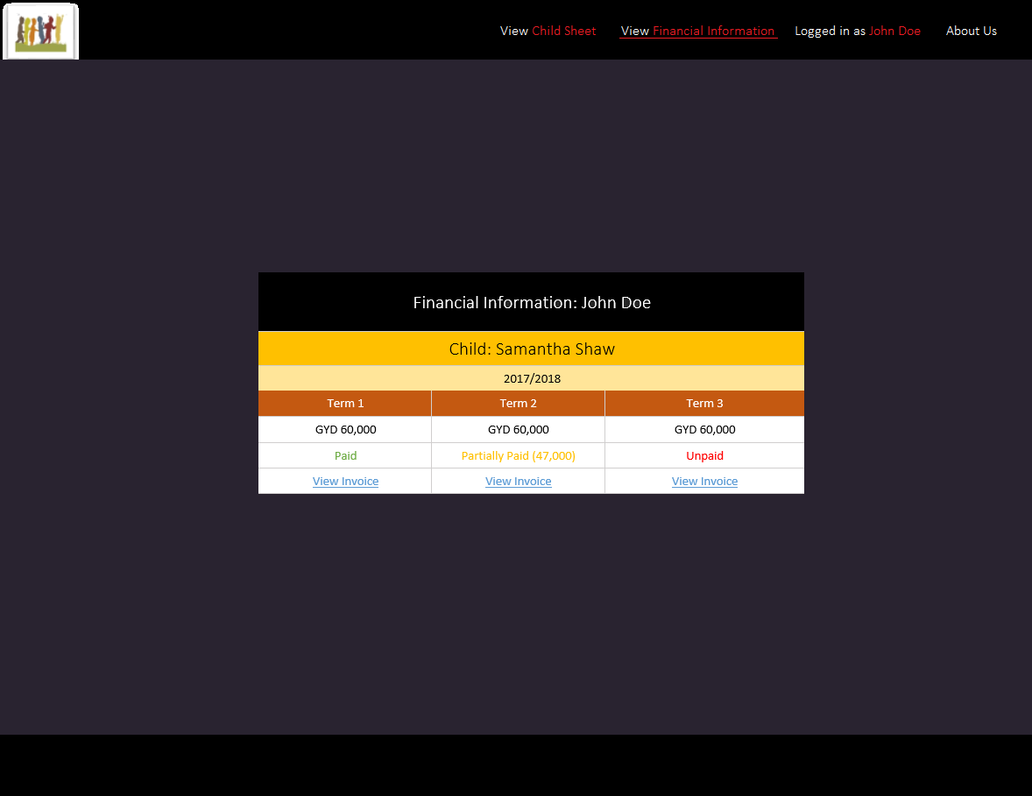

6.5 | About Us

